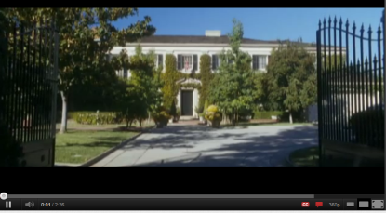  This is an establishing shot at the beginning of the trailer. | 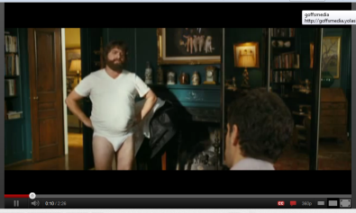  First act of comedy and also 2 characters are introduced. | 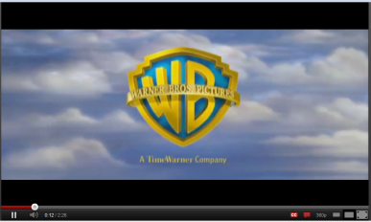  The company which are producing the film.
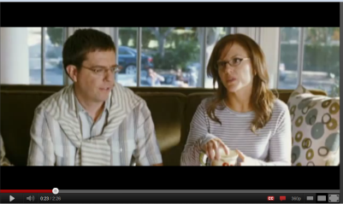  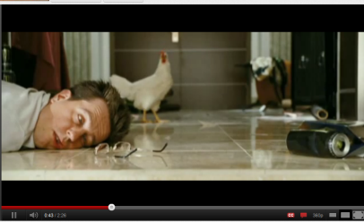  We are introduced to two new characters in this shot. | 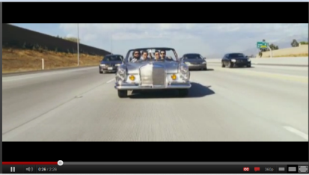  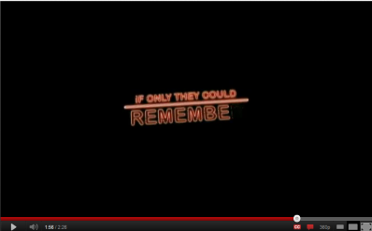  In this shot we are shown a group of friends travelling somewhere and in equilibrium. | 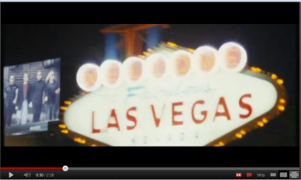  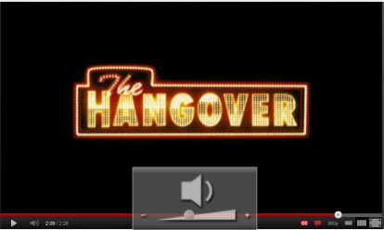  Another establishing shot showing that the film will be set in a new place.
It is the start of the disequilibrium where everything starts to go wrong. | A tag line which will help understand what’s happening in the trailer. The same font as the Vegas sign. | It ends on this shit to make sure you remember the film title. The font is similar to the shot before.
The Hangover - Comedy

This is a comedy trailer which starts off with an establishing shot of a big house, the trailer then carries on to show two characters talking, then out no where one of the characters has no trousers on and from then on you can tell this trailer is a comedy and not to be taken seriously. When you see the shot of the man in just his pants you can tell the other character has a funny reaction even though you are unable to see his face. The trailer then carries on to show two different production companies which are involved with the film, Warner Brothers & Legendary pictures, which people may have liked previous films they have made want to see this one just because of that reason. After the two productions company adverts have passed it goes back to the story and shows another two new characters which are talking. Through the dialogue you can tell this will be the serious one of the group of friends and maybe he will come to the rescue if they get stuck in trouble. The shot after shows four friends travelling somewhere in what looks like a very expensive car and everything seems normal because nothing strange or funny is happening at this point in time. This shot shows equilibrium in the story because everything is balanced and in order. The next shot completely changes the audience view though because it shows a sign of Las Vegas and the stereotype idea of this place is getting drunk, doing drunks, strip clubs and lots of gambling which is a totally different thing to what you expected them to be doing when driving the expensive car. This next shot is where everything turns and it shows where the disequilibrium kicks in and everything starts to go wrong. It makes you wonder how it started to go wrong and why it did, so it draws the audience’s attention to a rhetorical question which can only be answered by the film when it is released. An important phrase comes up in the next shot which sets the scene and gives the audience a bit of understanding and why they characters are so confused but it doesn’t give enough information to give away the storyline. The very last shot is the name of the film in the font which you can recognise and link to the film and other pieces of the film such as; the poster and when it has been featured on the front of a magazine. With this being the last shot they want the audience to remember the name of the film so they will talk about it to friends and advertise by word of mouth.
Mise-en-scene
There are many things which involve the mise-en-scene which make the trailer a comedy. For example when the first two characters we are introduced to are having a serious conversation and then one loses his trousers. Another part where the mise-en-scene obviously shows that the trailer is a comedy is when the character with glasses wakes up in the room they stayed in and you are able to see a chicken in the background. There is also other use of mise-en-scene to not only show that it’s a comedy but also to help set the scene, for example is when the characters end up in a police station and you can tell this because there are people dressed up in police officer outfits.
Narrative
The story has a very clear narrative about 4 friends who go on a trip to Las Vegas and wake up to not remember the night before. They then trace their steps back to find themselves in all sorts of different places. The trailer makes this very clear what happens but doesn’t give the story away because we only see snippets of what’s actually going on and it makes the audience want to know how they got to all these places the previous night which they are unable to remember.
Sound
The sound plays a big part in this trailer due to a lot of actions happening as the sound changes. A fast paced back tracking song is used to show time passed but when they wake up the next day it has slowed down to show that time is passing back at the normal rate of speed. There is also use of diegetic sound in the trailer to help the audience understand what is currently happening in the trailer in case some people are confused what’s going on. This is not only to add effect to the trailer but also used to make sure they keep the viewers attention because they feel they are now included in the trailer and feel more part of it.
Target Audience
The audience that this trailer is aiming for, is quite clear due to the age of the actors and the humour which is used. The actors used in the trailer are roughly between the ages of 23-30 years of age, so people of similar age will be able to connect to the characters better than an audience of 60 year olds. Also the humour in the trailer is quite random and immature which makes it seem like they are trying to also attract a teenage audience with it, it gives off the impression that they are trying to attract the attention of people between the ages of 16-20. Moreover they have also included a celebrity in the trailer (Mike Tyson) which will attract fans of the retired boxer, so people may go see the film just because he is in it.

